**DAILY ONLINE ACTIVITIES SUMMARY**

|  |  |  |  |  |  |  |  |  |
| --- | --- | --- | --- | --- | --- | --- | --- | --- |
| **Date:** | **28/05/2020** | | | | | **Name:** | **POOJA D S** | |
| **Sem & Sec** | **4th SEM 'B' Section** | | | | | **USN:** | **4AL18CS056** | |
| **Online Test Summary** | | | | | | | | |
| **Subject** | | **1.Microcontroller and Embedded Systems**  **2.Aadalitha Kannada** | | | | | | |
| **Max. Marks** | | **1.20**  **2.50** | | **Score** | | | **1.19**  **2.22** | |
| **Certification Course Summary** | | | | | | | | |
| **Course** | **Cloud Foundations** | | | | | | | |
| **Certificate Provider** | | | **Great Learning Academy** | | **Duration** | | | **4.5 hour** |
| **Coding Challenges** | | | | | | | | |
| **Problem Statement:** A user will input two strings, and we find if one of the strings is a sub sequence of the other. Program prints “yes” if either the first string is a sub sequence of the second string or the second string is a sub sequence of the first string. Assume that, the length of the first string is smaller than or equal to the length of the second string. Assume that, the length of the first string is smaller than or equal to the length of the second string. | | | | | | | | |
| **Status: completed** | | | | | | | | |
| **Uploaded the report in Github** | | | | | **yes** | | | |
| **If yes Repository name** | | | | | <https://github.com/dspooja/C-coding>  <https://github.com/dspooja/Java-coding> | | | |
| **Uploaded the report in slack** | | | | | **yes** | | | |

Online Test Details: (Attach the snapshot and briefly write the report for the same)

Certification Course Details: (Attach the snapshot and briefly write the report for the same)

Coding Challenges Details: (Attach the snapshot and briefly write the report for the same)

ONLINE TEST DETAILS:

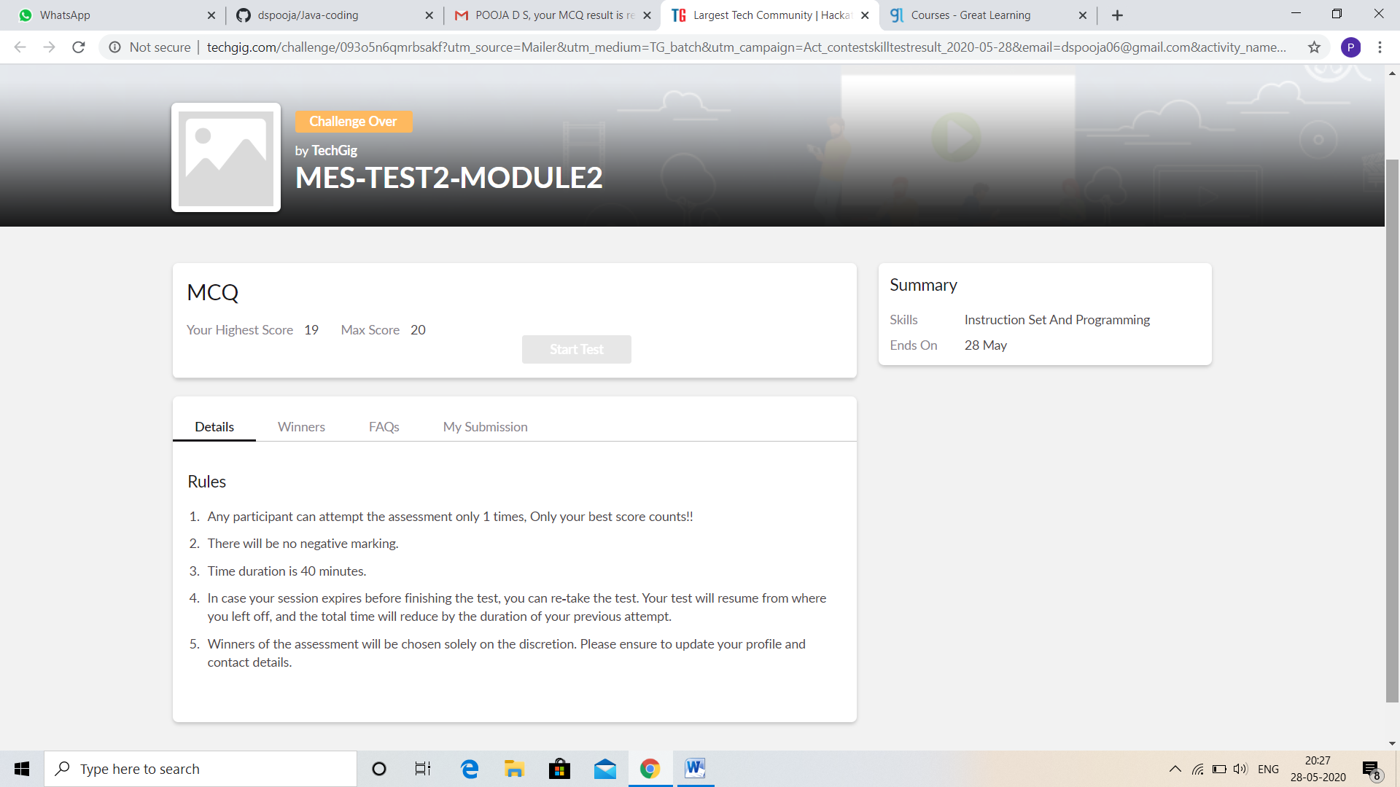

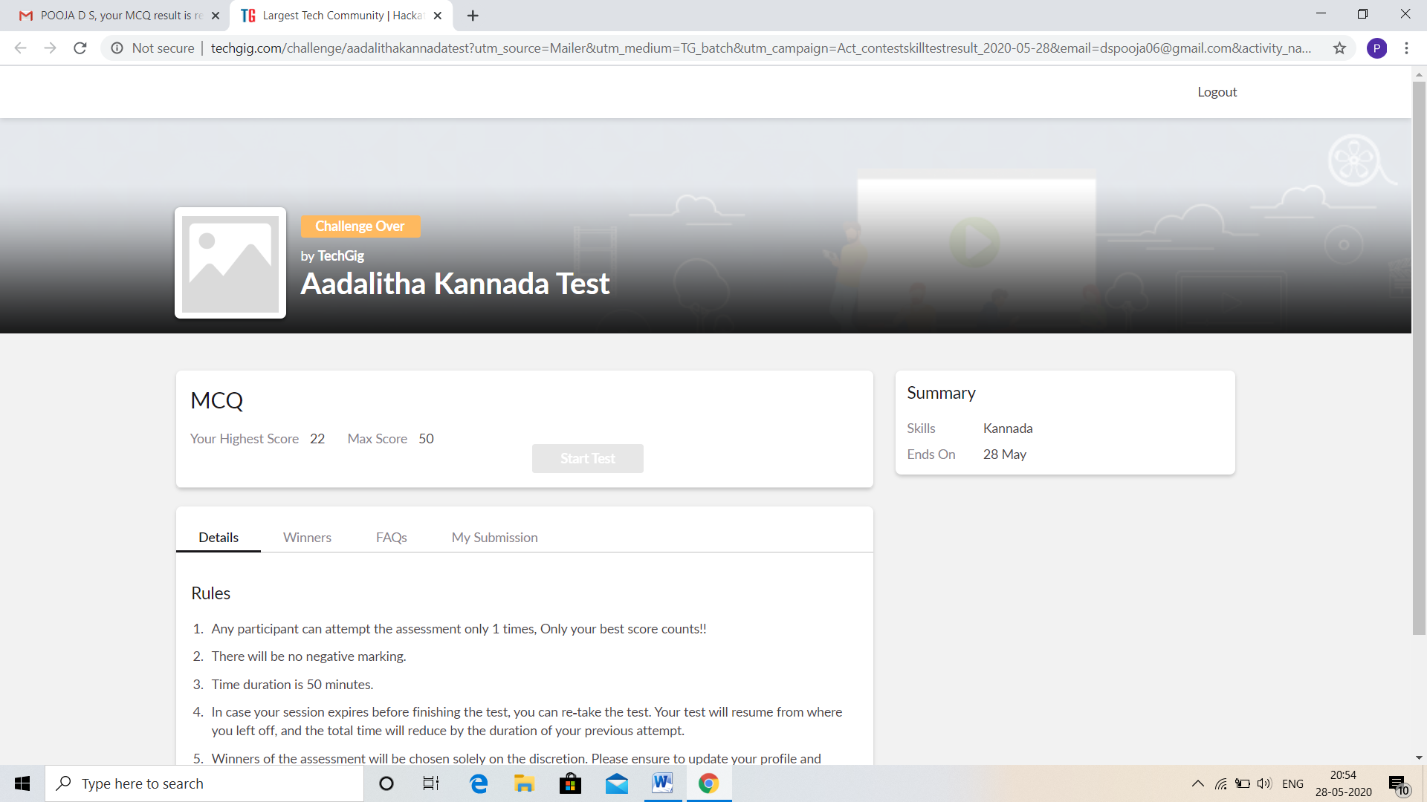

CERTIFICATION COURSE DETAILS:

* As continuation of the Cloud Foundation online course.
* **The concepts covered in** Cloud Foundation **are:**
* Introduction to Virtualization
* Containers vs VMs, Paas & Services Taxonomy
* Price Economics, Data Velocity & Distributed Computing
* Apps for Cloud & Security Model



CODING CHALLENGES DETAILS:

Problem statement 1:

C program to find digital root of a number

Description:  
A digital root is the recursive sum of all the digits in a number. Given n, take the sum of the digits of n. If that value has more than one digit, continue reducing in this way until a single-digit number is produced. This is only applicable to the natural numbers.  
digit_root(0)= 0

digital_root(16)  
=> 1 + 6  
=> 7

digital_root(132189)  
=> 1 + 3 + 2 + 1 + 8 + 9  
=> 24 ...  
=> 2 + 4  
=> 6

 Solution : Uploaded it in github

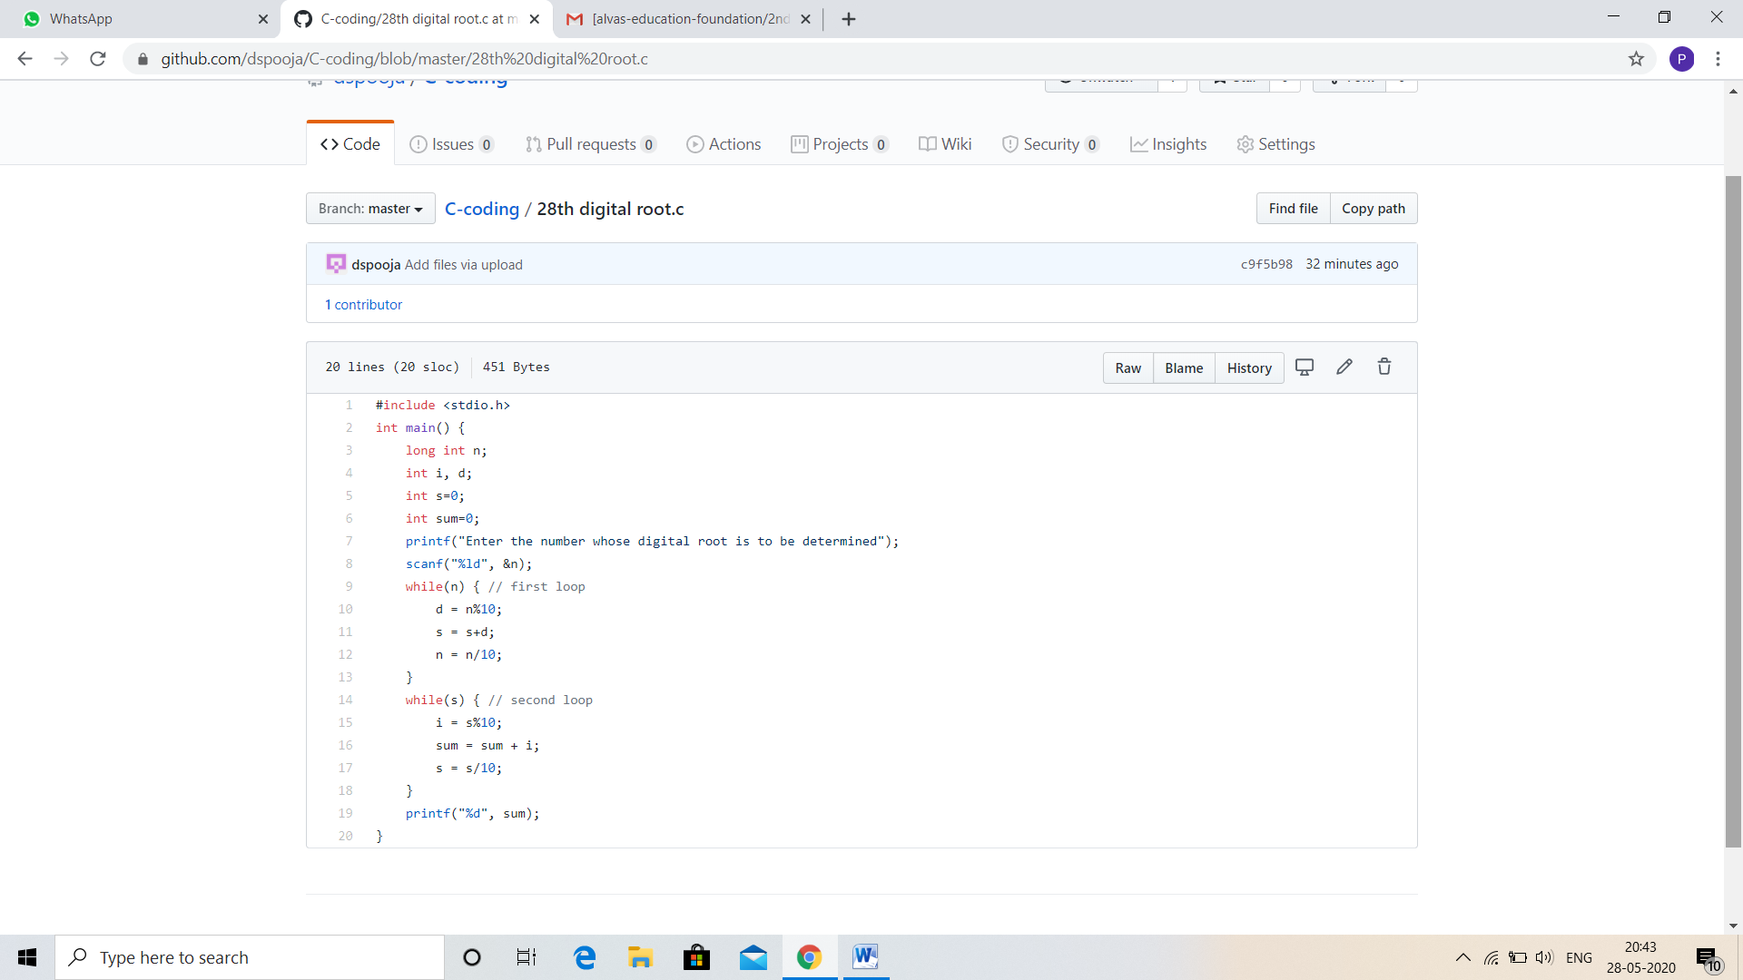

Problem statement 2:

In an array X of size M where the array elements contain values from 1 to M with duplicates, the task is to find total number of sub arrays which start and end with the same element.

Example:  
Input: X[] = {1, 2, 1, 5, 2}  
Output: 7  
Explanation:  
Total 7 sub-array of the given array are {1}, {2}, {1}, {5}, {2}, {1, 2, 1} and {2, 1, 5, 2} are start and end with same element.

Solution: Uploaded in github.

